John Weterick
May 19, 1859 – April 20, 1948

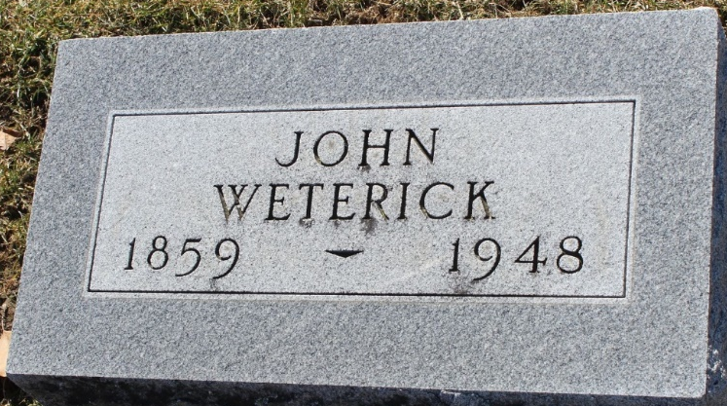
Photo by Tombstoner & Family

John Weterick
in the Indiana, U.S., Death Certificates, 1899-2017
Name John Weterick
Gender Male
Race White
Marital Status Married
Age 88
Birth Date 19 May 1859
Birth Place Switzerland
Death Date 20 Apr 1948
Death Place Bluffton, Wells, Indiana, USA
Death Registration Date 1948
Father Nicholas Weterick
Mother Elizabeth Brown
Spouse Elizabeth Yaney/Yancy?
Informant Mrs. Fred Dick; Bluffton, Indiana
Burial April 23, 1948; Elm Grove Cemetery; Bluffton, Indiana

