Frank Emil Weterick
May 15, 1892 – May 25, 1927

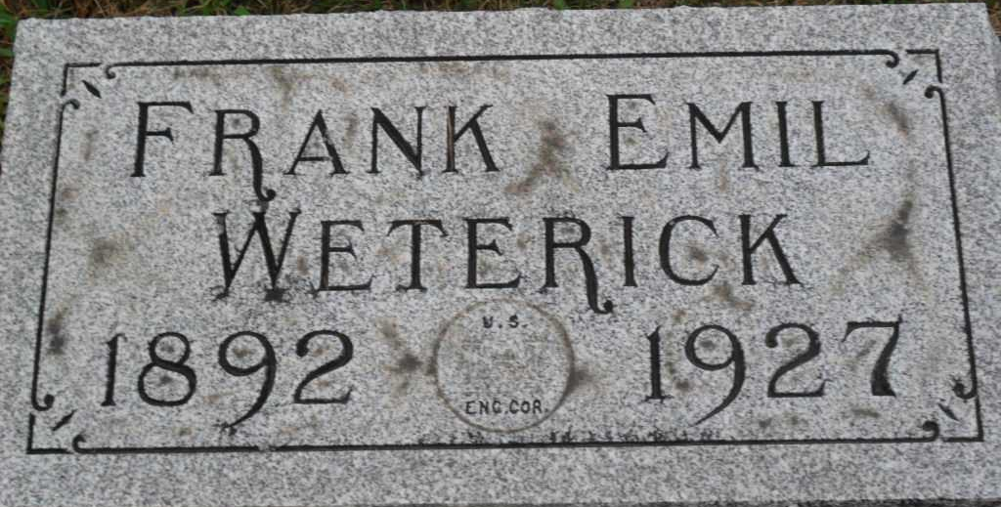
Photo by PLGS

Ohio, Deaths, 1908-1953

Name Frank E Weterick
Sex Male
Age 35 years, 10 days
Military Army
Birthplace Indiana
Residence Place Vera Cruz, , Indiana
Burial Date 25 May 1927
Burial Place Bluffton, , Indiana
Marital Status Single
Race W
Father's Name John Weterick
Father's Sex Male
Mother Unknown
Event Type Death
Event Date 25 May 1927
Event Place Chillicothe, Ross, Ohio
Event Place (Original) Chillicothe, Ross, Ohio
Source Details fn 31558

