Frances M. Weterick
July 9, 1895 – March 11, 1969

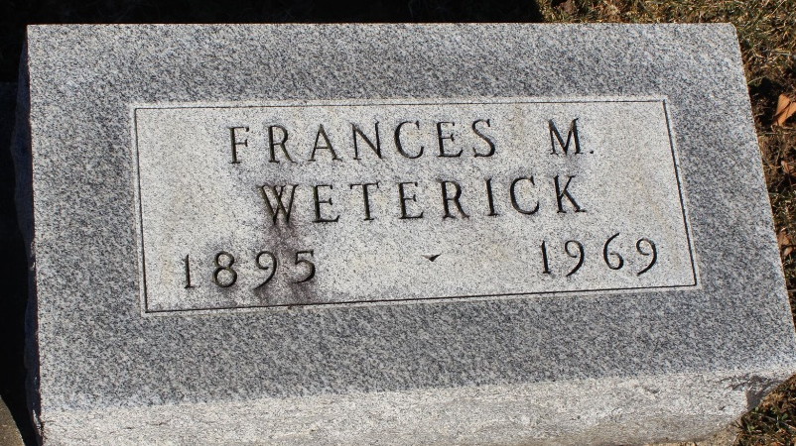
Photo by Tombstoner & Family

Miss Frances Weterick, 73, of 319 West Wabash ST., died Tuesday at Wells County Hospital. Born July 9, 1895, in Vera Cruz, she was a daughter of John and Elizabeth Jenni Weterick.
A resident of Wells County most of her life, she was a licensed practical nurse at the Allen County Nursing Home.
Surviving are two sisters, Mrs. Rose Dick, and Mrs. Elizabeth Shafer, both of Bluffton, and one brother, Ed Weterick of Red Hook, N.Y.
Services will be held at Thoma Funeral Home on Friday. Rev. Calvin Ley will officiate. Burial will be in Elm Grove Cemetery.

Wells County Obits, Wells County, Indiana
1969-1972

**
Indiana, U.S., Death Certificates, 1899-2017
Name Frances Weterick
Gender Female
Race White
Age 73
Marital Status Never Married (Single)
Birth Date 9 Jul 1895
Birth Place Indiana
Death Date 11 Mar 1969
Death Place Bluffton, Wells, Indiana, USA
Death Registration Date 1969
Father: John Weterick
Mother: Elizabeth Jenni
Informant: Rose Dick; sister; Bluffton, Indiana
Burial: March 14, 1969; Elm Grove Cemetery; Bluffton, Indiana

