Elizabeth (Yaney) Weterick
March 13, 1863 – June 16, 1946

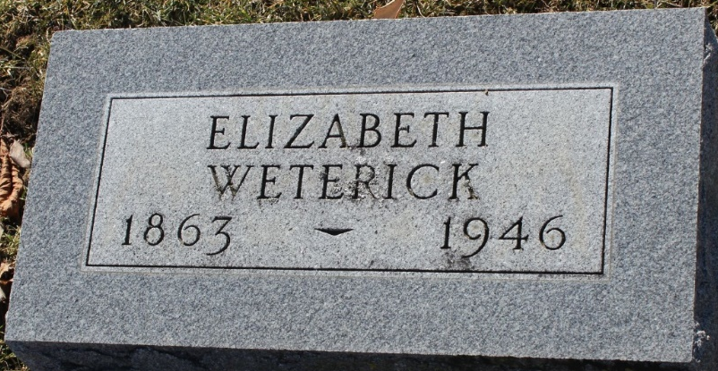
Photo by Tombstoner & Family

Elizabeth Weteerick
in the Indiana, U.S., Death Certificates, 1899-2017
Name Elizabeth Weterick
[Elizabeth Yaney]
Gender Female
Race White
Marital Status married
Age 83
Birth Date 13 Mar 1863
Birth Place Switzerland
Death Date 16 Jun 1946
Death Place Rural, Wells, Indiana, USA
Death Registration Date 1946
Father Nicholas Yaney
Mother Unknown
Spouse John Weterick; age 87
Informant John Weterick; Bluffton, Indiana
Burial June 19, 1946; Elm Grove Cemetery; Bluffton, Indiana

