Charles J. Weterick
May 19, 1888 – December 3, 1924

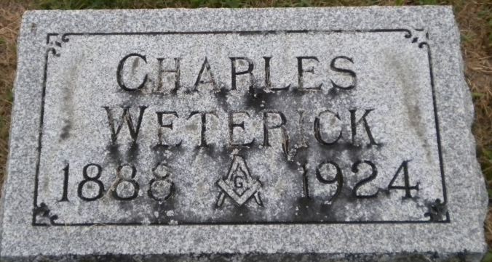
Photo by PLGS

Charles Wetrick
in the Indiana, U.S., Death Certificates, 1899-2017
Name Charles Wetrick
Gender Male
Race White
Marital Status Married
Age 36
Birth Date 19 May 1888
Birth Place Indiana
Death Date 3 Dec 1924
Death Place Bluffton, Wells, Indiana, USA
Death Registration Date 1924
Father John Wetrick
Mother Elizabeth Janney
Spouse Bertha McDonald
Informant Mrs. J. H. McGill; Bluffton, Indiana
Burial December 5, 1924; Elm Grove Cemetery

