Berta V. (McDonald) Weterick
February 23, 1889 – April 23, 1982

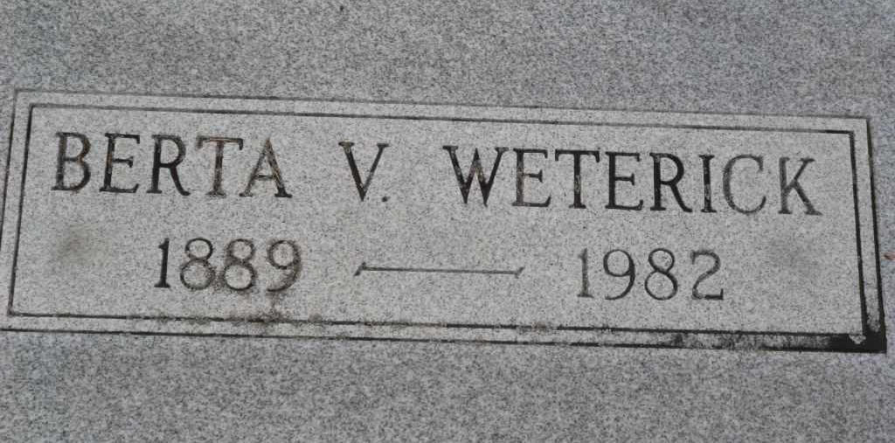
Photo by PLGS

Berta V. Weterick
in the Indiana, U.S., Death Certificates, 1899-2017

Name Berta V. Weterick
[Berta V. McDonald]
Gender Female
Race White
Marital Status Widowed
Age 93
Birth Date 23 Feb 1889
Birth Place Mississippi
Death Date 23 Apr 1982
Death Place Bluffton, Wells, Indiana, USA
Death Registration Date 1982
Father Robert S. McDonald
Mother Ida Bell Cappels
Informant Charles R. Weterick; Bluffton, Indiana
Burial April 26, 1982; Elm Grove Cemetery; Bluffton, Indiana

