Myrtle Alice (Farrel) Westervelt
February 24, 1889 – May 27, 1951

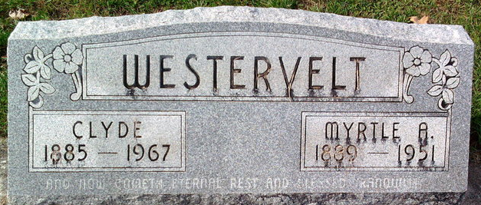
Photo by Thomas Liby

Mertle Alice Fanel
in the Indiana, U.S., Death Certificates, 1899-2017
Name Myrtle Alice Westervelt
Gender Female
Race White
Marital Status Married
Age 62
Birth Date 24 Feb 1889
Birth Place Jay County, Indiana
Death Date 27 May 1951
Death Place Montpelier, Blackford, Indiana, USA
Death Registration Date 1951
Father Moses M Farrel
Mother Abigail James
Informant Rev. Clyde Westervelt; Montpelier, Indiana
Burial May 30, 1951; Elm Grove Cemetery; Bluffton, Indiana

