Rev. Clyde T. Westervelt
March 24, 1885 – October 28, 1967

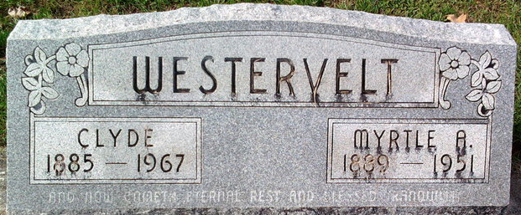
Photo by Thomas Liby

Clyde Westervelt
in the Indiana, U.S., Death Certificates, 1899-2017
Name Clyde Westervelt
Gender Male
Race Caucasian (White)
Marital Status Married
Age 82
Birth Date 24 Mar 1885
Birth Place Indiana
Death Date 28 Oct 1967
Death Place Muncie, Delaware, Indiana, USA
Death Registration Date 1967
Father Lot Westervelt
Mother Luella Edwards
Informant Amy Westervelt; wife; Muncie, Indiana
Burial October 30, 1967; Elm Grove Cemetery; Bluffton, Indiana

