Wanetta Maxine (Crozier) West
March 24, 1936 -

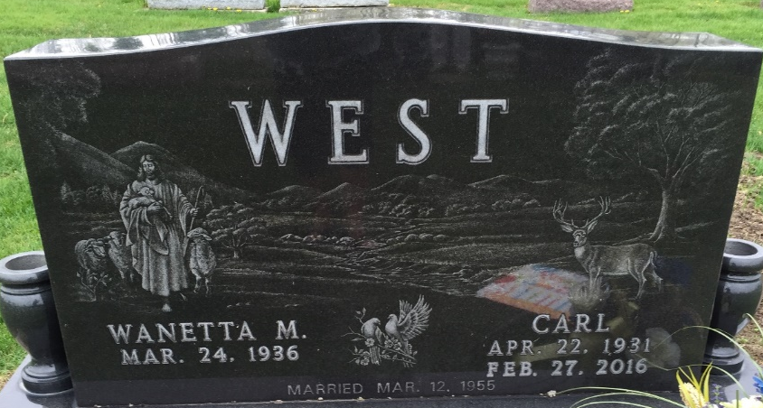
Photo by SMMR

Wanetta Maxine Crozier
in the Indiana, U.S., Birth Certificates, 1907-1944
Name Wanetta Maxine Crozier
Gender Female
Birth Date 24 Mar 1936
Birth Place Craigville, Wells, Indiana, USA
Father Francis Melvin Crozier; age 39
Mother Martha Alverta Leimenstoll; age 26; 3rd child, all living
Certificate Number 13344
Roll number 40474_357222
Volume Range 26 30

**
Indiana, U.S., Marriage Certificates, 1960-2012
Name Wanetta Maxine Crozier
Marriage Age 18
Birth Date 24 Mar 1936
Marriage Date 12 Mar 1955
Marriage Place Allen, Indiana, USA
Spouse Carl West

