Patricia Ann (Barton) West
January 30, 1940 – May 8, 2023

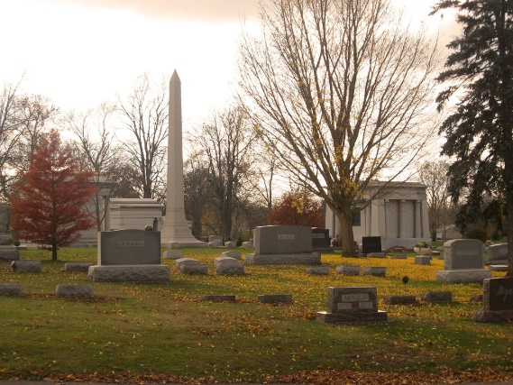
Photo by Tombstoner & Family

Patricia Ann “Pat” West, 83, of Bluffton, passed away Monday afternoon, May 8, 2023, at River Terrace Retirement Community.
Pat was born in Bluffton on Jan. 30, 1940, to Jay E. and Ada D. (Jones) Barton. Both parents preceded her in death.
Pat graduated from Bluffton High School in 1958 and was a long-time member of Park Community Church in Bluffton. She worked in the housekeeping department at Caylor Nickel Clinic for several years and later retired from Bluffton Rubber Company after over 20 years of service. Pat loved puzzles, especially jigsaw and crosswords, and also enjoyed volunteering at many different local organizations, including her church and the Wells County Public Library.
Survivors include a son, John (Becky) West of Bluffton; a daughter, Vicky (Chris) Carvalho of Pleasant View, TN; a sister, Nancy Barton of Bluffton; along with four grandchildren and 15 great-grandchildren.
In addition to her parents, Pat was preceded in death by a brother, Lenley “Bud” Barton.
Visitation will be Thursday, May 11, 2023, at Goodwin – Cale & Harnish Memorial Chapel, from 10:00 until 11:00 AM, followed by a funeral service at 11:00 AM. Pastor Dennis Wood will officiate. Burial will follow at Elm Grove Cemetery in Bluffton.
Memorial contributions may be made to Park Community Church in Bluffton.

Goodwin Funeral Home, Wells County, Indiana
May 9, 2023

