Carl West
April 22, 1931 – February 27, 2016

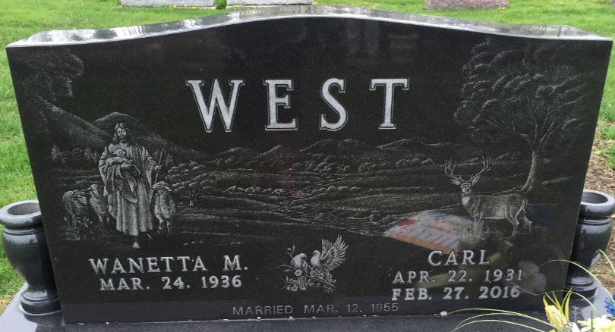
Photo by SMMR

Carl West 84, of Bluffton passed away peacefully surrounded by his family at 6:50 a.m. Saturday, Feb. 27, 2016, at Visiting Nurse and Hospice Home in Fort Wayne. Carl was born on April 22, 1931 in Lundsford, AR to Jesse and Alice (Owens)West.
He attended the Blevins High School and served our country in the United States Army from 1952 to 1954 during the Korean War and was honorably discharged as a sergeant. Carl was a truck driver and drove for General Electric and Blue Flame Gas in Bluffton and retired from driving for Sauder woodworking. He attended the Mulberry St. Wesleyan Church and currently Hope Missionary Church.
On March 12, 1955 in Craigville, Carl and Wanetta (Crozier) West were married.
Survivors include his wife of 61 years, Wanetta of Bluffton; a daughter, Sheryl Schwartz of Ft. Wayne; two grandchildren, Sean Schwartz of Ft. Wayne and Heather Helton of Bluffton; four great-grandchildren; and two brothers; Eulis West of Bluffton and John West of Winchester, IN.
He is preceded in death by his parents; a sister, Thelma Anders; and two infant sisters and four brothers, Vester, Chester, Paul and Ray West.
A service to celebrate Carl's life will be held at 10:30 a.m. Wednesday, March 2, at the Thoma/Rich Lemler Funeral Home in Bluffton. Pastor Don Hosier will officiate. Calling hours will be held on Tuesday from 2-8 p.m. and for one hour prior to the service. Burial will follow at Elm Grove Cemetery in Bluffton with military honors to be given by the United States Army Honor Guard and the American Legion post 111 of Bluffton.
Memorials may be made to Visiting Nurse & Hospice Home.

Thoma/Rich Funeral Home, Wells County, Indiana
February 28, 2016

