Tide W. Wertz
December 9, 1893 – April 10, 1926

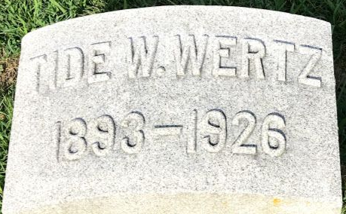
Photo by SMMR

FIVE KILLED IN AUTO MISHAPS
Couple Die as Motor Turns Over in Mint Canyon

With heavy Sunday traffic restored after the rains, the accident toll became heavy again yesterday. Five persons were killed and one is believed dying, while a number were less seriously hurt. The dead are T. W. Wertz of 2820 West Avenue 31, and his wife, Mrs. Nora B. Wertz, killed in Mint Canyon...
...Mr. and Mrs. Wertz and the latter's brother, William Miller, were on their way through Mint Canyon to hunt rabbits, according to the report of Constable Biddison at Newhall, Mrs. Wertz was driving. As they neared the summit of what is known as Long Grade, Mrs. Wertz apparently veered too far to the right and the front wheel struck soft dirt, the car overturning. Wertz met death almost instantly. Mrs. Wertz was crushed behind the steering wheel; Miller was severely bruised.

The Los Angeles Times; Los Angeles, California
Monday, April 12, 1926
**

U.S., World War I Draft Registration Cards, 1917-1918

Name Tide Wertz
Race Caucasian (White)
Marital Status Single
Birth Date 9 Dec 1893
Birth Place Ohio, USA
Residence Date 1917-1918
Street Address 2521 Maple Place
Residence Place Fort Wayne, Allen, Indiana, USA
Draft Board 3
Physical Build Medium
Height Short
Hair Color Dark Brown
Eye Color Gray
**
California, U.S., Death Index, 1905-1939
Name Tide W Wertz
Birth Year abt 1893
Death Date 10 Apr 1926
Age at Death 33
Death Place Los Angeles, California, USA
**
Tide W Wertz from tree James Family Tree
Birth 9 Dec 1893 Ohio, USA
Residence 1920 York, Sandusky, Ohio, USA
Marriage 18 Mar 1922 Jackson, Jackson, Michigan, USA
Death 10 Apr 1926 Los Angeles, California, USA
Father John Franklin Wertz (1861-1934)
Mother Caroline Fisher (Born 1869)
Spouse Nora Miller (1892-1926)

