Nora B. (Miller) Wertz
February 1892 – April 10, 1926

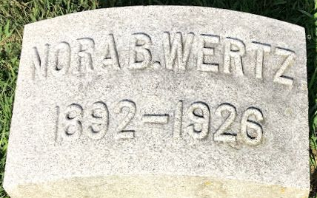
Photo by Thomas Liby

FIVE KILLED IN AUTO MISHAPS
Couple Die as Motor Turns Over in Mint Canyon
With heavy Sunday traffic restored after the rains, the accident toll became heavy again yesterday. Five persons were killed and one is believed dying, while a number were less seriously hurt. The dead are T. W. Wertz of 2820 West Avenue 31, and his wife, Mrs. Nora B. Wertz, killed in Mint Canyon...
...Mr. and Mrs. Wertz and the latter's brother, William Miller, were on their way through Mint Canyon to hunt rabbits, according to the report of Constable Biddison at Newhall, Mrs. Wertz was driving. As they neared the summit of what is known as Long Grade, Mrs. Wertz apparently veered too far to the right and the front wheel struck soft dirt, the car overturning. Wertz met death almost instantly. Mrs. Wertz was crushed behind the steering wheel; Miller was severely bruised.
The Los Angeles Times, Los Angeles, California
Monday, April 12, 1926
**
California, U.S., Death Index, 1905-1939
Name Nora B Wertz
Birth Year abt 1891
Death Date 10 Apr 1926
Age at Death 35
Death Place Los Angeles, California, USA
**
Nora Miller from tree James Family Tree
Birth Feb 1892 Wells, Indiana, USA
Residence 1900 Bartholomew, Indiana, USA
Marriage 18 Mar 1922 Jackson, Jackson, Michigan, USA
Death 10 Apr 1926 Los Angeles, California, USA
Father Thomas Wilson Miller (1856-1911)
Mother Amanda Elizabeth Hey (1857-1927)
Spouse Tide W Wertz (1893-1926)

