J. Franklin Wertz
November 21, 1861 – October 18, 1934

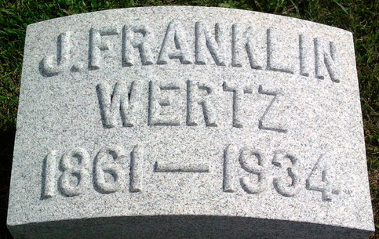
Photo by Thomas Liby

Je Franklin Werts
in the Indiana, U.S., Death Certificates, 1899-2017
Name J. Franklin Wertz
Gender Male
Race White
Marital Status Married
Age 72
Birth Date 21 Nov 1861
Birth Place Bryan, Ohio
Death Date 18 Oct 1934
Death Place Fort Wayne, Allen, Indiana, USA
Death Registration Date 1934
Father John Wertz
Mother Elizabeth Grindle
Spouse Carolyn
Informant Mrs. Carolyn Wertz; Fort Wayne, Indiana
Burial October 20, 1934; Bluffton, Indiana

