Gussie Wertz
December 18, 1891 – October 10, 1911

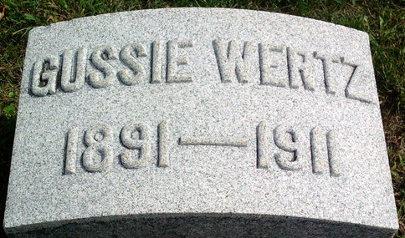
Photo by Thomas Liby

Gussie Wertz
in the Indiana, U.S., Death Certificates, 1899-2017
Name Gussie Wertz
Gender Male
Race White
Marital Status Single
Age 19
Birth Date 18 Dec 1891
Birth Place Montpelier Ohio
Death Date 10 Oct 1911
Death Place Bluffton, Wells, Indiana, USA
Death Registration Date 1911
Father John F Wertz
Mother Edith Carie
Informant W. L. Kiger; Bluffton, Indiana
Burial October 12, 1911; Elm Grove Cemetery

