Carolyn Elizabeth Wertz
August 26, 1923 – August 26, 1923

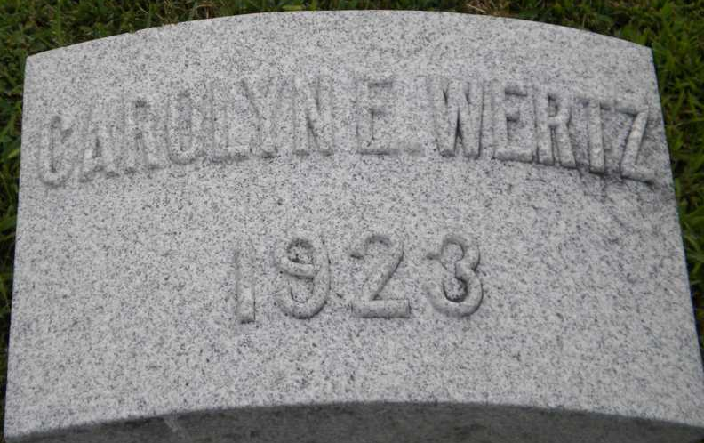
Photo by PLGS

Carolyn Elizabeth Wertz
in the Indiana, U.S., Death Certificates, 1899-2017
Name Carolyn Elizabeth Wertz
Gender Female
Race White
Marital Status Single
Age 0
Birth Date 26 Aug 1923
Birth Place Indiana
Death Date 26 Aug 1923; stillborn
Death Place Fort Wayne, Allen, Indiana, USA
Death Registration Date 1923
Father Tide W. Wertz
Mother Nora B. Miller
Informant Mrs. John Wertz
Burial August 28, 1923; Bluffton, Indiana

