William M. Welsh
March 30, 1929 – January 5, 2007

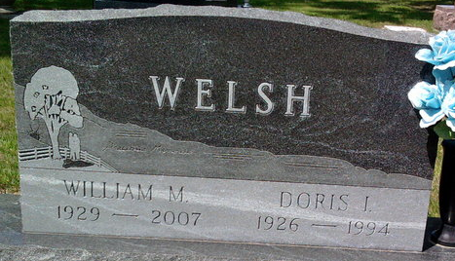
Photo by Thomas Liby

William M Welsh
in the Indiana, U.S., Death Certificates, 1899-2017
Name William M Welsh
Gender Male
Race White
Marital Status Widow
Age 77
Birth Date 30 Mar 1929
Birth Place Wells County, Indiana
Death Date 5 Jan 2007
Death Place Fort Wayne, Allen, Indiana, USA
Death Registration Date 2007
Father Kenneth Welsh
Mother Esther Smith
Informant Cindy Studebaker; daughter; Bluffton, Indiana
Burial January 8, 2007; Elm Grove Cemetery; Bluffton, Indiana

