Mary Annetta Welsh
April 15, 1948 – September 5, 1958

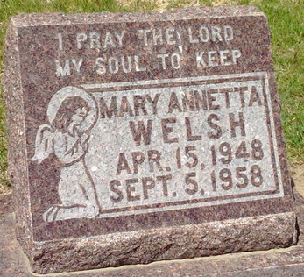
Photo by Thomas Liby

Mary Annetta Welsh
in the Indiana, U.S., Death Certificates, 1899-2017
Name Mary Annetta Welsh
Gender Female
Race White
Marital Status Never Married (Single)
Age 10
Birth Date 1948
Birth Place Indiana
Death Date 5 Sep 1958
Death Place Bluffton, Wells, Indiana, USA
Death Registration Date 1958
Father William Welsh
Mother Doris Groh
Informant William Welsh; father; Bluffton, Indiana
Burial September 7, 1958; Elm Grove Cemetery; Bluffton, Indiana

**
Mary Annetta Welsh from tree BETTS Family Tree
Birth 15 Apr 1948 Indiana, USA
Residence 1958 Bluffton, Wells, Indiana, USA
Death 5 Sep 1958 Bluffton, Wells, Indiana, USA
Father William Max Welsh (1929-2007)
Mother Doris Irene Groh (1926-1994)

