Doris Irene (Groh) Welsh
July 13, 1926 – April 13, 1994

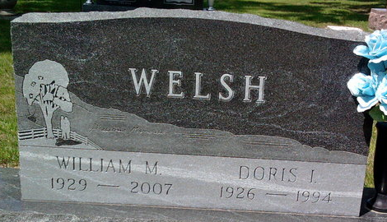
Photo by Thomas Liby

Doris Irene Welsh
in the Indiana, U.S., Death Certificates, 1899-2017

Name Doris Irene Welsh
[Doris Irene Groh]
Gender Female
Race White
Marital Status Married
Age 67
Birth Date 13 Jul 1926
Birth Place Wells County, Indiana
Death Date 13 Apr 1994
Death Place Bluffton, Wells, Indiana, USA
Death Registration Date 1994
Father Carl Groh
Mother Naomi Householder
Spouse William Welsh
Informant William Welsh; husband; Bluffton, Indiana
Burial April 16, 1994; Elm Grove Cemetery; Bluffton, Indiana

