Walter Louis Wells
October 16, 1919 – February 14, 2000

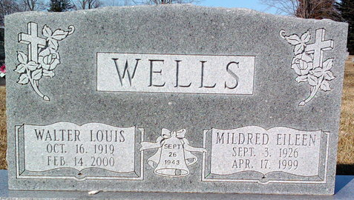
Photo by Thomas Liby

Walter L. Wells
in the Indiana, U.S., Death Certificates, 1899-2017
Name Walter L. Wells
Gender Male
Race White
Marital Status Widowed
Age 80
Birth Date 16 Oct 1919
Birth Place Elwood, Indiana
Death Date 14 Feb 2000
Death Place Connersville, Fayette, Indiana, USA
Death Registration Date 2000
Father Otto Cedell Wells
Mother Cecil Claire Widner
Informant Stephen Wells; son; Ann Arbor, Michigan
Burial February 18, 2000; Elm Grove Cemetery; Bluffton, Indiana

