Mildred Eileen (Harris) Wells
September 3, 1926 – April 17, 1999

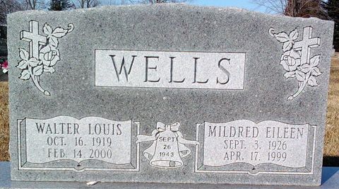
Photo by Thomas Liby

Mildred E. Wells
in the Indiana, U.S., Death Certificates, 1899-2017
Name Mildred E. Wells
[Mildred E. Harris]
Gender Female
Race White
Marital Status Married
Age 72
Birth Date 3 Sep 1926
Birth Place Wells County, Indiana
Death Date 17 Apr 1999
Death Place Connersville, Fayette, Indiana, USA
Death Registration Date 1999
Father William R. Harris
Mother Blanche Lenora Godwin
Spouse Walter L. Wells
Informant Stephen Wells; son; Ann Arbor, Michigan
Burial April 21, 1999; Elm Grove Cemetery; Bluffton, Indiana

