Elmer P. Wells
February 13, 1888 – July 29, 1973

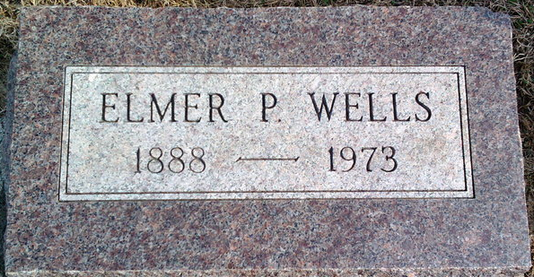
Photo by Thomas Liby

Elmer Wells
in the Indiana, U.S., Death Certificates, 1899-2017
Name Elmer Wells
Gender Male
Race White
Age 85
Birth Date 13 Mar 1881 [sic]
Birth Place Indiana
Death Date 29 Jul 1973
Death Place Fort Wayne, Allen, Indiana, USA
Death Registration Date 1973
Parents Not named
Informant Mrs. Kenneth Wells
Burial July 31, 1973; Elm Grove Cemetery; Bluffton, Indiana

**
Elmer P Wells from tree Marks x Family Tree
Birth 13 Feb 1888 Whitley, Indiana, USA
Residence 1951 Indiana, USA
Death Jul 1973
Father Aaron Wells (1849-1931)
Mother Eliza Alice Binkley (1859-1929)

