Henry Ludwig Weinman
November 19, 1901 – April 8, 1940

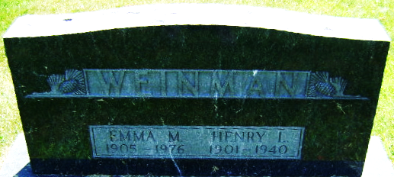
Photo by Bruce Sonner

Henry Ludwig Weinman
in the Michigan, U.S., Death Records, 1867-1952
Name Henry Ludwig Weinman
Gender Male
Race White
Marital Status Married
Death Age 38
Birth Date 19 Nov 1901
Birth Place Altica Ind
Death Date 8 Apr 1940
Death Place Ann Arbor, Washtenaw, Michigan, USA
Father Jacob Weinman
Mother Theresa
Spouse Emma Motz; age 34
Informant Mrs. Henry Weinman; Lansing, Michigan
Burial April 11, 1940; Elm Grove Cemetery; Bluffton, Indiana
File Number 010066

