Emma M. (Motz) Weinman
December 13, 1905 – August 8, 1976

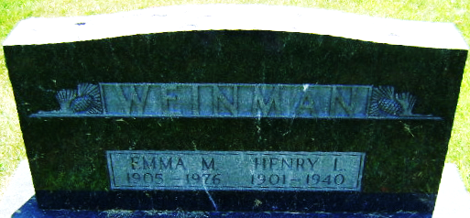
Photo by Bruce Sonner

Mrs. Emma M. (Weinman) Motz, 71, of Charlevoix, Michigan who died at 10:30 pm Sunday at the Charlevoix Hospital. She had been in ill health for some time.
She was born December 13, 1905, a daughter of George and Wilmetta Kitchen Motz. Her marriage to Henry L. Weinman, who died in 1940, took place in March 1925 in Ohio.
Surviving is a daughter, Mrs. Max (Joyce) Hosmer of Charlevoix; a brother, Robert Motz of Lansing; two sisters, Mrs. Georgiana Captain of Great Falls, Michigan and Mrs. Inez Mendenhall of Charlevoix, and two grandchildren.
Graveside rites will be at 2 pm Wednesday at the Elm Grove Cemetery.

Bluffton News-Banner, Wells County, Indiana
August 9, 1976

**
Michigan, U.S., Death Index, 1971-1996
Name Emma M Weinman
Birth Date 13 Dec 1905
Death Date 8 Aug 1976
Gender Female
Residence Charlevoix, Charlevoix, Michigan
Place of Death South Arm, Charlevoix, Michigan

**
Ohio, U.S., County Marriage Records, 1774-1993
Name Emma M. Motz
Gender Female
Marriage Age 21
Birth Date abt 1904
Marriage Date 14 Mar 1925
Marriage Place Henry, Ohio, USA
Father George E. Motz
Mother Wilmetta Ritshen Or Kitshen
Spouse Henry L. Weinman

