Otto Henry Weilemann
June 17, 1888 – November 9, 1966

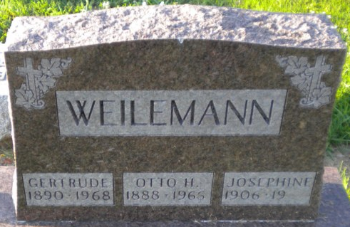
Photo by PLGS

Otto Henry Weilemann
in the Florida, U.S., Death Index, 1877-1998
Name Otto Henry Weilemann
Gender Male
Race White
Death Date Nov 1966
Death Place Manatee, Florida, United States

**
U.S., Social Security Death Index, 1935-2014
Name Otto Weilemann
Social Security Number xxx
Birth Date 18 Jun 1888
Issue year Before 1951
Issue State Indiana
Last Residence 33505, Bradenton, Manatee, Florida, USA
Death Date Nov 1966

**
Indiana, U.S., Marriages, 1810-2001

Name Otto H Weilemann
Gender Male
Race White
Age 62
Event Type Marriage Registration (Marriage)
Birth Date 17 Jun 1888
Birth Place Adams, Indiana
Marriage Date 28 Nov 1950
Marriage Place Indiana, United States
Residence Place Bluffton
Father Henry Weilemann
Mother Caroline Bardlemier
Spouse Josephine Sprowl
Page 496

**
Otto Henry Weilemann from tree Weilemann Family Tree

Birth 17 Jun 1888 Adams, Indiana, USA
Marriage 23 Jun 1907
Residence 1920 Bluffton, Wells, Indiana, USA
Death 9 Nov 1966
Father Henry John Weilemann (1867-1927)
Mother Carline Bardelmeier (1872-1932)
Spouse Gertrude Viola Parrish (1891-1968)
Spouse Josephine Hessher (1906-2002)

