Josephine (Hesher) Weilemann
November 29, 1906 – October 25, 2002

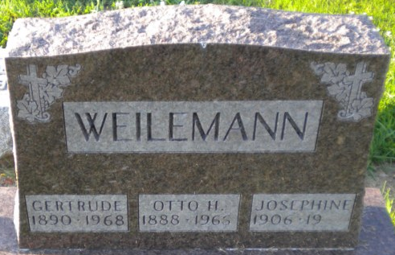
Photo by PLGS

Josephine Weilemann
in the U.S., Social Security Applications and Claims Index, 1936-2007
Name Josephine Weilemann
[Josephine Hesher Sprowl]
[Josephine Hesher]
Gender Female
Race White
Birth Date 29 Nov 1906
Birth Place Bluffton, Indiana
Death Date 25 Oct 2002
Claim Date 3 Jul 1957
Father Bert Hesher
Mother Louise Borne
SSN xxx
Notes Jun 1957: Name listed as JOSEPHINE WEILEMANN
**
Josephine Hesher from tree Davis Family Tree

Birth 29 Nov 1906 Wells, Indiana, USA
Marriage 28 Nov 1950 Wells, Indiana, USA
Residence 1953 Bluffton, Wells, Indiana, USA
Death 25 Oct 2002
Father Bert McClaine Hesher (1875-1919)
Mother Louise Katherine Borne (1879-1954)
Spouse Noble Ernest Shields (Born 1905)
Spouse Leroy Sherwood Sprowl (1901-1958)
Spouse Otto H Weilemann (Born 1888)

