Gertrude Viona (Parrish) Weilemann
June 22, 1890 – June 7, 1968

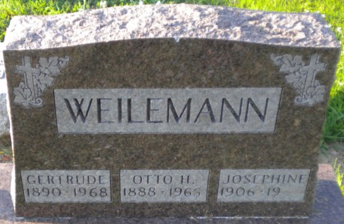
Photo by PLGS

Mrs. Gertrude Weilemann, 77, formerly of Bluffton, died at Richmond State Hospital Friday. Born in Adams County, June 21, 1890, she was the daughter of Jesse and Mary Bell Parrish. She was the first wife of the late Otto Weilemann, Bluffton plumbing shop owner.
Surviving is a son, Luzerne Weilemann of Fort Wayne; three grandchildren; three brothers and two sisters, Joseph and Vincent Parrish, both of Wisconsin, Mrs. Lucile Helms, Herman Parrish and Mrs. Ruth Evans, all three of Muncie.
Mrs. Weilemann was a member of the First United Church of Christ in Bluffton and the WBA.
Graveside rites will be conducted at 2:30 pm Sunday at Elm Grove Cemetery in charge of Rev. Calvin Ley.

Bluffton News-Banner, Wells County, Indiana
June 7, 1968

**
Indiana, U.S., Death Certificates, 1899-2017

Name Gertrude Weilemann
Gender Female
Race White
Marital Status Widow
Age 77
Birth Date 22 Jun 1890
Birth Place Indiana
Death Date 7 Jun 1968
Death Place Rural, Wayne, Indiana, USA
Death Registration Date 1968
Father Unk
Mother Unk
Informant Hospital records; Richmond State Hospital; Richmond, Indiana
Burial June 9, 1968; Elm Grove Cemetery; Bluffton, Indiana
**
Indiana, U.S., Marriages, 1810-2001
Name Gertrude Viona Parrish
Gender Female
Race Light
Age 16
Event Type Marriage Registration (Marriage)
Birth Date 22 Jun 1890
Birth Place Adams, Indiana
Marriage Date 19 Jun 1907
Marriage Place Indiana, United States
Residence Place Adams, Indiana
Father Jessie M Parrish
Mother Mary D Bell
Spouse Otto Henry Weilemann

