Robert Edward Wedding
August 12, 1943 – October 5, 1998

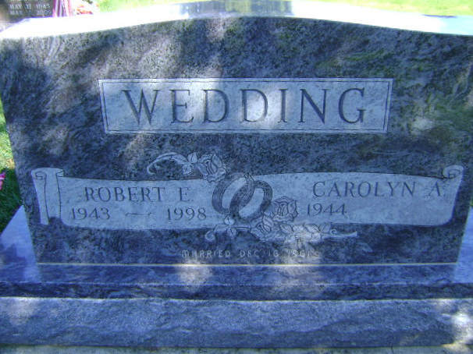
Photo by Bruce Sonner

Robert Edward Wedding, 55, of Greensburg, Pa., died Monday at Westmoreland Regional Hospital in Greensburg. Born in Owensboro, Ky., he worked for Corning Inc. with the American Video Division for 33 years.
Survivors include two sons, Robert Dale and Brian, both of Bluffton; and a daughter, Rhonda Elzey of Bluffton.
Services at 1 p.m. Saturday at Goodwin Memorial Chapel in Bluffton. Calling from 7 to 9 p.m. Thursday at Kepple-Graft Funeral Home, Greensburg, Pa., and from 11 a.m. until service time at Goodwin Memorial Chapel. Interment in Elm Grove Cemetery.

Journal Gazette, Allen County, Indiana
Wednesday, October 7, 1998

