Carolyn A. (Griggs) Wedding
1944 -

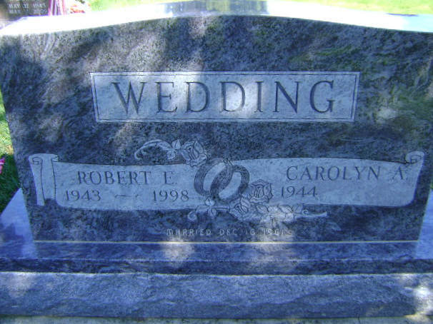
Photo by Bruce Sonner

