Mary E. (Painter) Webber
September 10, 1898 – September 23, 1997

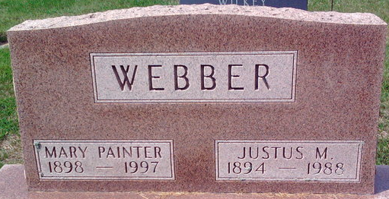
Photo by Thomas Liby

Mary P. Webber
in the Indiana, U.S., Death Certificates, 1899-2017
Name Mary P. Webber
[Mary P. Painter]
Gender Female
Race White
Marital Status Widowed
Age 99
Birth Date 10 Sep 1898
Birth Place Bluffton, Indiana
Death Date 23 Sep 1997
Death Place Bluffton, Wells, Indiana, USA
Death Registration Date 1997
Father John Painter
Mother Ida R. Walmer
Informant Dorothy Wilkey; daughter; Bluffton, Indiana
Burial September 26, 1997; Elm Grove Cemetery; Bluffton, Indiana

