Justus M. Webber
December 14, 1894 – January 29, 1988

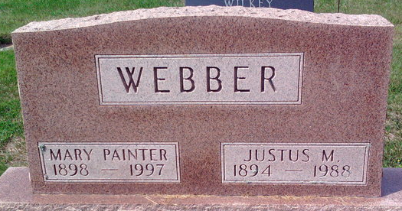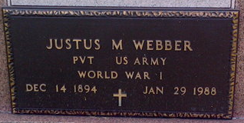
Photo by Thomas Liby

Justus M Webber
in the Indiana, U.S., Death Certificates, 1899-2017
Name Justus M Webber
Gender Male
Race Caucasian (White)
Marital Status Married
Age 93
Birth Date 14 Dec 1894
Birth Place Warren, Indiana
Death Date 29 Jan 1988
Death Place Bluffton, Wells, Indiana, USA
Death Registration Date 1988
Father Harry C Webber
Mother Agnes Justus
Spouse Mary Painter
Informant Mary Webber; wife; Bluffton, Indiana
Burial February 1, 1988; Elm Grove Cemetery; Bluffton, Indiana

