Richard L. Weaver
February 27, 1925 – August 5, 1970

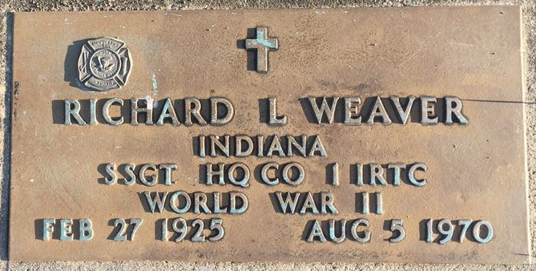
Photo by Bruce Sonner

RICHARD WEAVER DIES AT 45 YEARS
Services were held last Saturday, August 8, 1970 at the Olson, Reiser and Frum Chapel in East Gary for Richard Weaver, 3103 E. 35th Avenue, Gary formerly of Hobart, who passed away at home, Wednesday, August 5, 1970 at the age of 45.
Mr. Weaver who was employed at the time of his death at Krughoff Company in Chesterton worked for Hobart Lumber for many years and many of the homes in the area are the richer for his suggestions and drawings.
Mr. Weaver was a veteran of World War II and was a member of American Legion Post 214 of Glen Park and of Liverpool-Oregon Volunteer Fire Department.
He is survived by his wife, Blanche; 2 daughters, Darlene and Karen, 4 sons, Paul, Richard, Roger, and Keith, all at home; 2 sisters, Mrs. Frank Pond of Ft. Wayne and Mrs. Max Mann of Mt. Pelier, Indiana. Rev. Allan D. Byrne officiated at the services. Burial was in Elm Grove Cemetery, Bluffton, Indiana.

Unknown source

**
Indiana, U.S., Death Certificates, 1899-2017
Name Richard L Weaver
Gender Male
Race White
Marital Status Married
Age 45
Birth Date 27 Feb 1925
Birth Place Ohio
Death Date 5 Aug 1970
Death Place Gary, Lake, Indiana, USA
Father Paul Weaver
Mother Mary Mahon
Spouse Blanch Schnell
Informant Mrs. Blanch Weaver; wife; Gary, Indiana
Burial August 8, 1970; Elm Grove Cemetery; Bluffton, Indiana

