Rena M. (DeWitt) Watters
December 30, 1866 – January 14, 1953

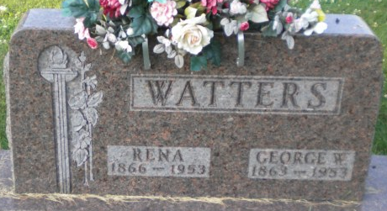
Photo by PLGS

Rena Watters
in the Indiana, U.S., Death Certificates, 1899-2017
Name Rena Watters
[Rena Dewitt]
Gender Female
Race White
Marital Status Widowed
Age 86
Birth Date 30 Dec 1866
Birth Place Indiana
Death Date 14 Jun 1953
Death Place Bluffton, Wells, Indiana, USA
Death Registration Date 1953
Father Worthy Dewitt
Mother Elizabeth Moyer
Informant Mrs. Floyd Miller
Burial June 17, 1953; Elm Grove Cemetery; Bluffton, Indiana

