Ora C. Watters
February 27, 1894 – June 4, 1978

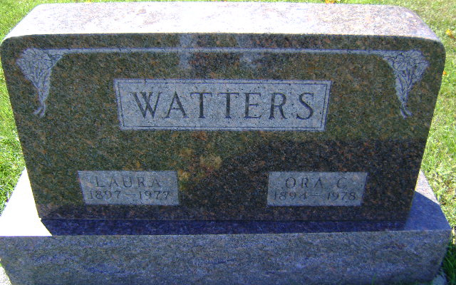
Photo by Bruce Sonner

Ora C Waters
in the Indiana, U.S., Death Certificates, 1899-2017
Name Ora C Waters
Gender Male
Race White
Marital Status Widowed
Age 84
Birth Date 27 Feb 1894
Birth Place Indiana
Death Date 4 Jun 1978
Death Place Bluffton, Wells, Indiana, USA
Death Registration Date 1978
Father George Watters
Mother Rena Dewitt
Spouse Laura E Helms; deceased
Informant Mrs. Ben (Rena) Soper; Liberty Center, Indiana
Burial June 7, 1978; Elm Grove Cemetery; Bluffton, Indiana

