Laura Elizabeth (Helms) Watters
January 16, 1897 – August 6, 1977

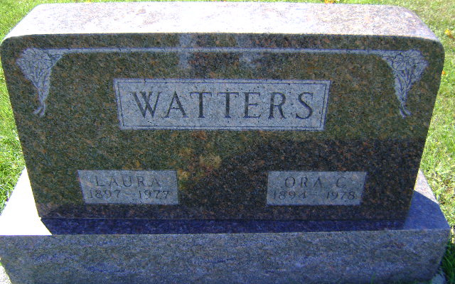
Photo by Bruce Sonner

Laura Elizabeth Watters
in the Indiana, U.S., Death Certificates, 1899-2017
Name Laura Elizabeth Watters
[Laura Elizabeth Helms]
Gender Female
Race White
Marital Status Married
Age 80
Birth Date 16 Jan 1897
Birth Place Indiana
Death Date 6 Aug 1977
Death Place Bluffton, Wells, Indiana, USA
Death Registration Date 1977
Father John L Helms
Mother Cordelia Ratiff
Spouse Ora C Watters
Informant Ora C. Watters; husband; Bluffton, Indiana
Burial August 9, 1977; Elm Grove Cemetery; Bluffton, Indiana

