Huston D. Watters
October 21, 1928 -

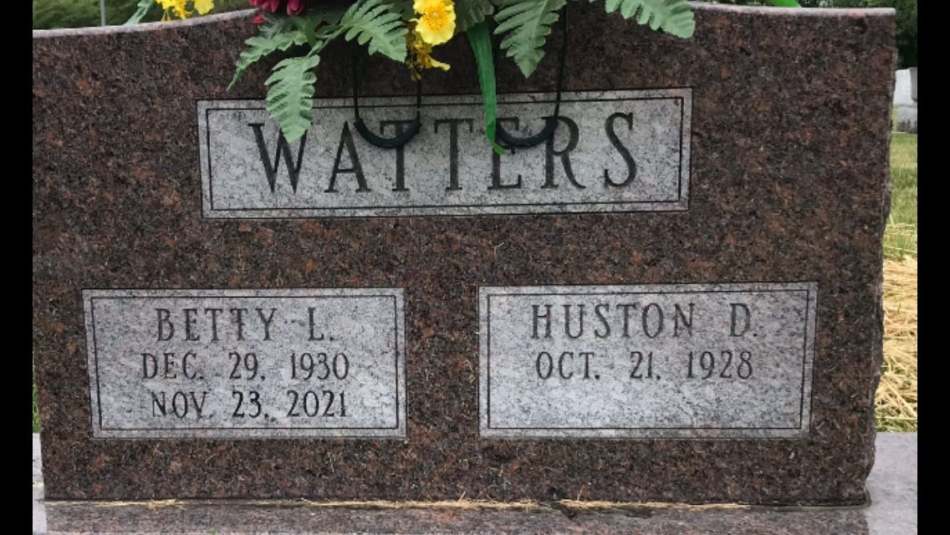
Photo by PLGS

Huston D Watters
in the Indiana, U.S., Marriages, 1810-2001
Name Huston D Watters
Gender Male
Race White
Age 22
Event Type Marriage Registration (Marriage)
Birth Date 21 Oct 1928
Birth Place Wells, Indiana
Marriage Date 30 Sep 1950
Marriage Place Indiana, United States
Residence Place Bluffton, Indiana
Father Chancy E Watters
Mother Helen Helms
Spouse Betty Lou Kiefer
Page 465
FHL Film Number 002318672

