Helen M. (Helms) Watters
November 23, 1902 – April 18, 1979

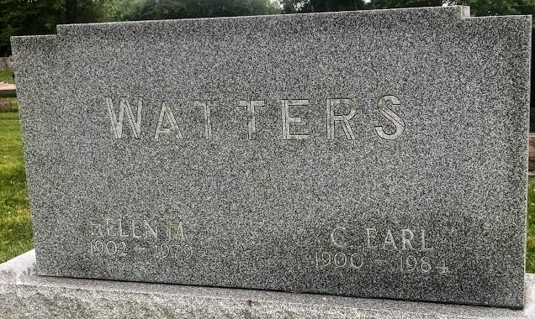
Photo by SMMR

Helen M. Watters
in the Indiana, U.S., Death Certificates, 1899-2017
Name Helen M. Watters
[Helen M. Helms]
Gender Female
Race White
Marital Status Married
Age 76
Birth Date 23 Nov 1902
Birth Place Indiana
Death Date 18 Apr 1979
Death Place Bluffton, Wells, Indiana, USA
Death Registration Date 1979
Father John Helms
Mother Cordelia Rattliff
Spouse Chauncey Earl Watters
Informant Chauncey Earl Watters; Bluffton, Indiana
Burial April 21, 1979; Elm Grove Cemetery; Bluffton, Indiana

