George W. Watters
October 1, 1863 – February 5, 1953

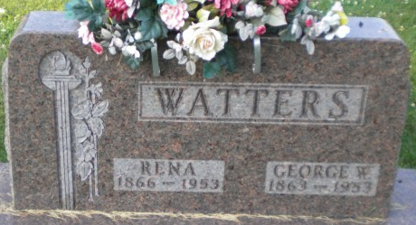
Photo by PLGS

George Watters
in the Indiana, U.S., Death Certificates, 1899-2017
Name George Watters
Gender Male
Race White
Marital Status Married
Age 89
Birth Date 1 Oct 1863
Birth Place Ohio
Death Date 5 Feb 1953
Death Place Bluffton, Wells, Indiana, USA
Death Registration Date 1953
Father William Watters
Mother Jane Johnson
Informant Mrs. Floyd Miller, Bluffton, Indiana
Burial February 8, 1953; Elm Grove Cemetery; Bluffton, Indiana

