Chauncey Earl Watters
March 1, 1900 – December 12, 1984

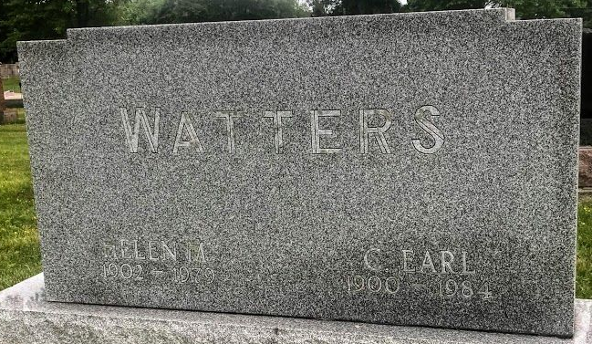
Photo by SMMR

Chauncey Earl Watters
in the Indiana, U.S., Death Certificates, 1899-2017
Name Chauncey Earl Watters
Gender Male
Race White
Marital Status Widowed
Age 84
Birth Date 1 Mar 1900
Birth Place Indiana
Death Date 12 Dec 1984
Death Place Bluffton, Wells, Indiana, USA
Death Registration Date 1984
Father George W. Watters
Mother Rena De Witt
Informant Lovina Hunnicutt; daughter; Bluffton, Indiana
Burial December 15, 1984; Elm Grove Cemetery; Bluffton, Indiana

