Betty Lou (Kiefer) Watters
December 29, 1930 – November 23, 2021

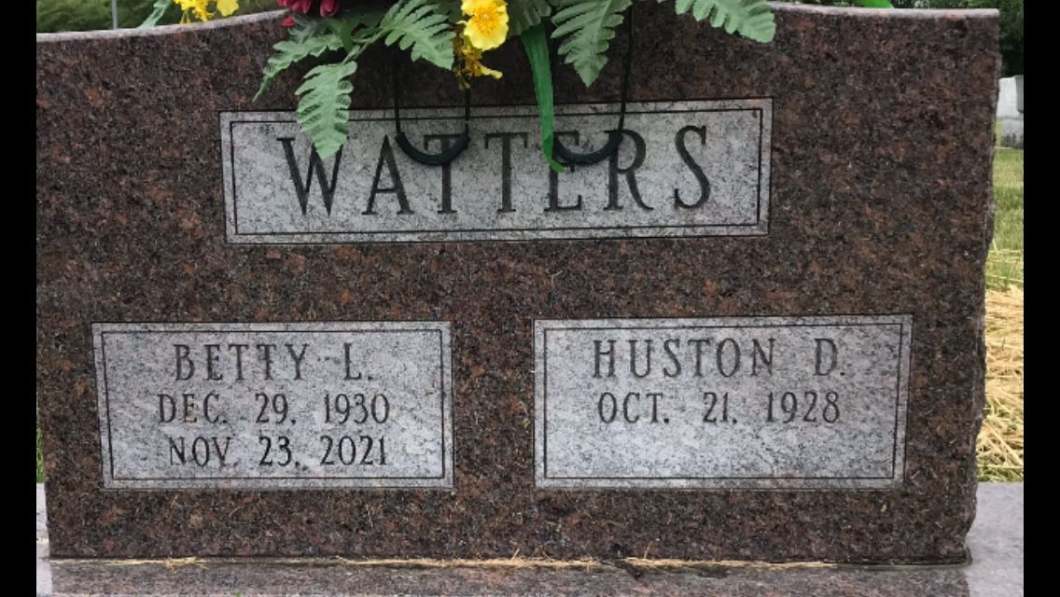
Photo by PLGS

Bettie Lou Kiefer
in the Indiana, U.S., Birth Certificates, 1907-1944
Name Bettie Lou Kiefer
Gender Female
Birth Date 29 Dec 1930
Birth Place Bluffton, Wells, Indiana, USA
Father Ralph Kiefer; age 23
Mother Maud M. Little; age 22; 1st child
Certificate Number 58937
Roll number 40474_356506
Volume Range 116 - 119

**
U.S., Cemetery and Funeral Home Collection, 1847-Current
Name Betty L. Watters
[Betty L. Kiefer]
Gender Female
Death Age 90
Birth Date 29 Dec 1930
Birth Place Wells County
Marriage Date 1 Oct 1950
Marriage Place Bluffton
Residence Place Bluffton
Death Date 23 Nov 2021
Death Place Fort Wayne
Burial Date 29 Nov 2021
Obituary Date 12 Mar 2022
Father Ralph F. Kiefer
Child Victoria Uhlemann; Douglas J. Watters; Kathy Ankenbruck
Siblings Patricia J. Moser

