Mary B. (Swisher) Watson
September 12, 1853 – February 25, 1927

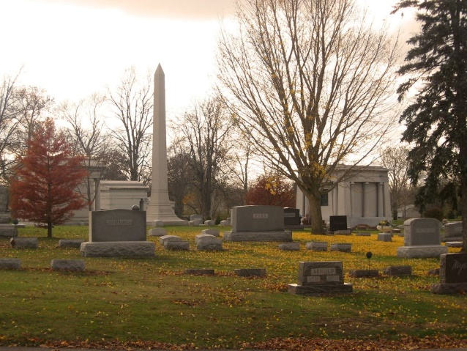
Photo by Tombstoner & Family

Bluffton Indiana - Feb. 25 – Mrs. Mary Watson, 73, wife of Albert Watson for forty-two years a resident of Bluffton, died at 8 o'clock this morning at the county hospital here of acute nephritis.
Surviving are the husband and a brother, George Swisher, of Marion.
Funeral services will be held at the residence, 828 West Washington, at 2 o'clock Sunday afternoon, with burial at Elm Grove.

The Star Press, Delaware County, Indiana
Saturday, February 26, 1927

**
Indiana, U.S., Death Certificates, 1899-2017
Name Mary Watson
[Mary Swisher]
Gender Female
Race White
Marital Status Married
Age 73
Birth Date 12 Sep 1853
Birth Place Van Bureu Indiana
Death Date 25 Feb 1927
Death Place Bluffton, Wells, Indiana, USA
Death Registration Date 1926-1927
Father Andrew Swisher
Mother Blair
Spouse Albert Watson
Informant Albert Watson; Bluffton, Indiana
Burial February 27, 1927; Elm Grove Cemetery

