Albert Watson
February 21, 1855 – December 2, 1935

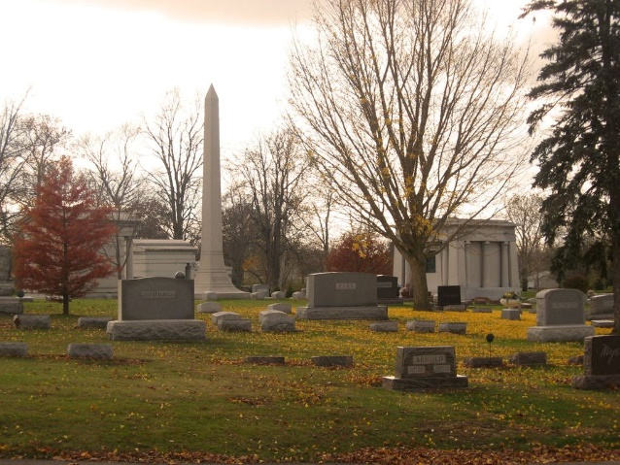
Photo by Tombstoner & Family

Albert Watson
in the Indiana, U.S., Death Certificates, 1899-2017
Name Albert Watson
Gender Male
Race White
Marital Status Widowed
Age 80
Birth Date 21 Feb 1855
Birth Place Indiana
Death Date 2 Dec 1935
Death Place Bluffton, Wells, Indiana, USA
Death Registration Date 1935
Father Wm Watson
Mother Elizabeth Heffner
Spouse Mary Blair Swisher
Informant Mrs. Howard Hesher; Bluffton, Indiana
Burial December 4, 1935; Elm Grove Cemetery

