Stella L. (Vaughn) Watkins-Chalfant
October 11, 1883 – May 28, 1971

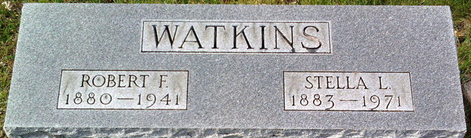
Photo by Thomas Liby

Stella L Chalfant
in the Indiana, U.S., Death Certificates, 1899-2017
Name Stella L Chalfant
[Stella L Vaughn]
Gender Female
Race White
Marital Status Widowed
Age 87
Birth Date 11 Oct 1883
Birth Place Indiana
Death Date 28 May 1971
Death Place Gary, Lake, Indiana, USA
Father Turner Vaughn
Mother Unknown [Anna Ward]
Informant Clayton Watkins; son
Burial June 1, 1971; Elm Grove Cemetery; Bluffton, Indiana

**
Indiana, U.S., Marriages, 1810-2001
Name Stella Vaughn
Gender Female
Race White
Marriage Date 1 Jan 1902
Marriage Place Indiana, United States
Residence Place Indiana
Spouse Robert Watkins
Page 25
FHL Film Number 002318977

**
Indiana, U.S., Marriages, 1810-2001
Name Stella Watkins
Gender Female
Marriage Date 10 Apr 1946
Marriage Place Indiana, United States
Spouse Donn J Chalfant
Page 363
FHL Film Number 002416452

