Robert Franklin Watkins
March 5, 1880 – November 28, 1941

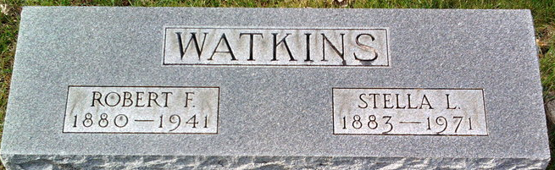
Photo by Thomas Liby

Robert Franklin Watkins
in the Indiana, U.S., Death Certificates, 1899-2017
Name Robert Franklin Watkins
Gender Male
Race White
Marital Status Married
Age 61
Birth Date 5 Mar 1880
Birth Place Indiana
Death Date 28 Nov 1941
Death Place Gary, Lake, Indiana, USA
Death Registration Date 1941
Father Joseph Watkins
Mother Martha J Steele
Spouse Stella; age 58
Informant Stella L. Watkins
Burial December 1, 1941; Elm Grove Cemetery

