William T. Wasson
February 26, 1868 – July 2, 1963

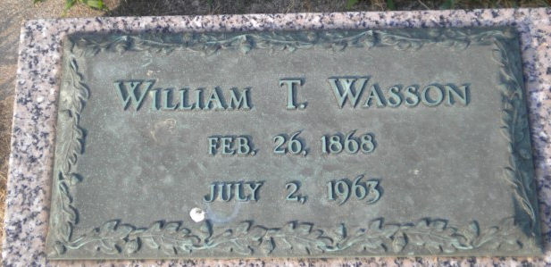
Photo by Bruce Sonner

William T Wasson
in the Indiana, U.S., Death Certificates, 1899-2017
Name William T Wasson
Gender Male
Race White
Marital Status Widowed
Age 95
Birth Date 26 Feb 1868
Birth Place Wells County, Indiana
Death Date 2 Jul 1963
Death Place Bluffton, Wells, Indiana, USA
Death Registration Date 1963
Father George Wasson
Mother Loretta A Woodward
Informant Warner Wasson; son; Muncie, Indiana
Burial July 5, 1963; Elm Grove Cemetery; Bluffton, Indiana

