Wendell J. Wasson
January 25, 1904 – March 2, 1978

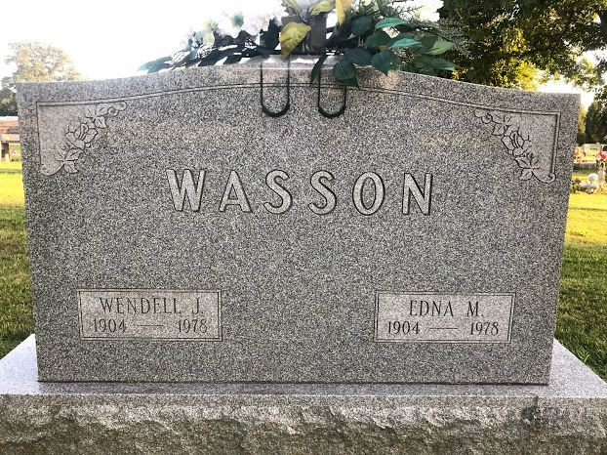
Photo by SMMR

MISS & MASTER OWNER DIES
Wendell J. Wasson, 74, of 4706 Tacoma Ave. died at 7:30 a.m. Thursday in Parkview Memorial Hospital. Mr. Wasson, a native of Tocsin, lived in Fort Wayne most of his life. He owned Miss and Master Children's Clothing Store for the past 20 years.
Surviving is his wife, Edna M.; a daughter, Mrs. James Ostrognai, Indianapolis; a son, Robert, Fort Wayne; and a sister, Mrs. Opal Berlien, Fort Wayne.
Services will be at 1:30 p.m. Saturday in Chalfant-Perry-Klaehn Funeral Home, where friends may call from 3 to 5 and 7 to 9 p.m. Friday. Burial will be in Elm Grove Cemetery in Bluffton.

Journal Gazette, Allen County, Indiana
Friday, March 2, 1978

**
Indiana, U.S., Death Certificates, 1899-2017
Name Wendell J Wasson
Gender Male
Race Caucasian (White)
Marital Status Married
Age 74
Birth Date 25 Jan 1904
Birth Place Indiana
Death Date 2 Mar 1978
Death Place Fort Wayne, Allen, Indiana, USA
Death Registration Date 1978
Father Irvin Wasson
Mother Etta Mae Sowards
Spouse Edna M
Informant Edna M. Wasson; Fort Wayne, Indiana
Burial March 4, 1978; Elm Grove Cemetery; Bluffton, Indiana

