Vera Grace (Decker) Wasson
March 26, 1912 – January 14, 2007

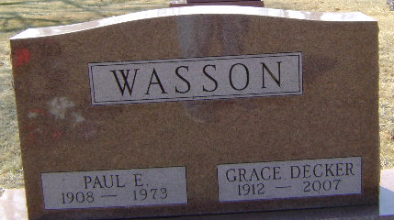
Photo by PLGS

Vera Grace (Decker) Wasson, 94, of Bluffton died at 6:30 a.m. on Sunday, Jan. 14, 2007 at the Christian Care Retirement Community where she had been a resident for the past four years.
She was born on March 26, 1912 in Rock Creek Township, a daughter of Otto R. and Osma (Buell) Decker. She was a 1929 graduate of Bluffton High School. She was a lifelong resident of Bluffton, and a member of the First Reformed Church in Bluffton (United Church of Christ) for 70 years. She was married in Bluffton on Aug. 11, 1935 to Paul E. Wasson, who preceded her in death on Aug. 31, 1973.
She is survived by two sons, Don E. (Susan) Wasson of Albuquerque, N.M., and Ted (Patricia) Wasson of Bloomfield, Mich., and Bonita Springs, Fla., along with four grandchildren and eight great-grandchildren. She was preceded in death by three brothers, John, Brooks, and Rex Decker, and her sister Mary Helen Cochrun.
Calling is from 10 a.m. to noon on Saturday, Jan. 20, at the Thoma/Rich, Hewitt & Chaney Funeral Home. A graveside service will be held at 1 p.m. on Saturday at Elm Grove Cemetery with Rev. Gene Bell of the First Reformed Church officiating.
Memorials may be made to the charity of the donor's choice.

Thoma/Rich Funeral Home, Wells County, Indiana
January 15, 2007

