Vella Dawn (Sylvester) Wasson
May 2, 1924 – September 29, 2012

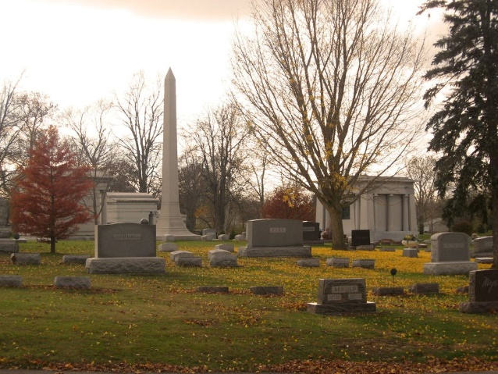
Photo by Tombstoner & Family

Vella Dawn Wasson, 88, of Decatur, passed away Saturday September 29, 2012 at Woodcrest Nursing Center. She was born in Mars Hill, Maine on May 2, 1924 to the late Fred Alden and Hazel I. (Shaw) Sylvester. On May 25, 1996 she married Richard L. Wasson.
Vella Dawn was a member of the First United Methodist Church in Decatur. She had a lengthy career in the pleasure boat industry specifically in Duo Marine. In 1970 she partnered with Richard Wasson, Vic Porter and others to form Signa Corporation. She was also an office manager at Thunderbird Products until her retirement.
She is survived by her husband, Richard L. Wasson, of Decatur, IN, and daughters: Sandra (Robert) Auer of Kissimmee, FL., Jill (Michael) Burke of Mooresboro, NC., and Jackie (Blanca Garcia) Teeple of Woodland, CA., 5 grandchildren and 12 great-grandchildren.
Vella Dawn was preceded in death by her first husband Robert Turner, her second husband Robert Teeple, a grandson Mark Alden Auer, one brother, two half-brothers, and two half-sisters.
Visitation will be held on Tuesday October 2nd at Woodcrest Porter Auditorium from 1130am – 1230pm and from 5:00 – 7:00pm at Haggard Sefton & Hirschy Funeral Home. Funeral services will follow visitation at 7:00pm at the funeral home.
Memorial contributions may be made to First United Methodist Church (Fishes and Loaves) or Family Life Care. (hospice)
Burial will be at Elm Grove Cemetery in Bluffton, Indiana. Rev. Martha Lyon will officiate.

Haggard & Sefton Funeral Home, Adams County, Indiana
September 30, 2012

