Vada (Woodward) Wasson
September 19, 1901 – June 9, 1992

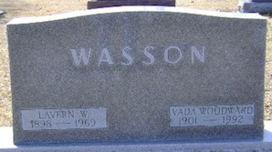
Photo by Bruce Sonner

Vada Wasson
in the Indiana, U.S., Death Certificates, 1899-2017
Name Vada Wasson
[Vada Woodward]
Gender Female
Race White
Marital Status Widowed
Age 90
Birth Date 19 Sep 1901
Birth Place Wells County, Indiana
Death Date 9 Jun 1992
Death Place Bluffton, Wells, Indiana, USA
Death Registration Date 1992
Father Wilson Woodward
Mother Luella Somer
Informant Richard Wasson; son; Decatur, Indiana
Burial June 11, 1992; Elm Grove Cemetery; Bluffton, Indiana

