Sarah E. (Sweeny) Wasson
February 12, 1845 – July 6, 1908

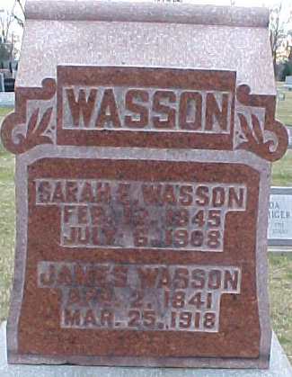
Photo by Bruce Sonner

Sarah E Wasson
in the Ohio, U.S., Rutherford B. Hayes Presidential Center Obituary Index, 1810s-2016
Name Sarah E Wasson
Death Date 6 Jul 1908
Newspaper Information Newspaper: Wayne County Democrat, Newspaper Date: 08 Jul 1908, Newspaper Page: P6 Column: ; Repository: WAYNE COUNTY PUBLIC LIBRARY (WOOSTER); Years Available: 1850-1913
**
Sarah E. Sweeney from tree The Plummer, Wasson, Sowards, Jones, Sweeny, Hall, Trullender, Roop Line
Birth 12 Feb 1845 Wayne, Ohio, USA
Marriage 16 Nov 1870 Wells, Indiana, USA
Residence 1900 Wells, Indiana, USA
Death 6 Jul 1908 Wells, Indiana, USA
Father Robert G. Sweeny (1794-1858)
Mother Sarah Colborn (1802-1860)
Spouse James Wasson (1841-1918)

